**SYNOPSIS ON**

**“EcoFill: Sustainable Water Tank Management Using IoT”**

Submitted in

Partial Fulfillment of requirements for the Award of Degree *of*

Bachelor of Technology

*In*

Computer Science and Engineering

*(Internet of Things)*

By

**(Project Id:05)**

**Shruti Singh (21016415500)**

**Ashumendra Pratap Singh (2101641550027)**

**Harshit Sharma (2101641550042)**

**Kavya Chaurasia (2101641550045)**

**Shivanshu Gupta (2101641550067)**

Under the supervision of

**Rajat Verma**

**(Assistent. Professor)**



**Pranveer Singh Institute of Technology**.

Kanpur - Agra - Delhi National Highway - 19 Bhauti -Kanpur - 209305.

(Affiliated to Dr. A.P.J. Abdul Kalam Technical University)

1. **Introduction**

In today's world, where many places face water shortages, imagine a project called EcoFill that's like a technological superhero for water tanks. It's here to change the way we deal with our water storage systems by using the Internet of Things (IoT).

Right now, managing water tanks can be a bit old-fashioned and not very efficient. People often have to check and control them manually, which can be a hassle. Sometimes, too much water is wasted, and other times, the tanks aren't filled enough. This is where EcoFill steps in.

EcoFill's big idea is to make your water tank smart. It connects to the internet, just like your phone or computer, and this allows it to do some really cool things. First, it can fill your water tank all by itself, without you having to do anything. It's like magic! It knows exactly how much water your tank needs, so it doesn't waste any, and it never leaves your tank too empty.

But here's the really awesome part: EcoFill doesn't take away your control. You can still decide when and how your tank gets filled. You can switch between letting it work automatically or doing it manually, like using a remote control.

EcoFill also keeps an eye on things and tells you how you're using water. It's like having a super-smart water assistant. It can even help you spot if there's a problem, like a leak, so you can fix it quickly.

Now, why is all of this important? Because it's not just about making our lives easier. It's also about taking care of our planet. EcoFill helps us use water more wisely and avoid wasting it. This is a big deal because water is precious, and we need to make sure there's enough for everyone.

So, EcoFill isn't just a project; it's a superhero project for your water tank. It's all about making water management smart, simple, and kind to the environment. In the sections that come next, we'll dig deeper into how this superhero project will work, who will benefit from it, and what challenges it might face.

1. **Project Objective**

The primary objectives of the EcoFill project are as follows:

* Develop an IoT-based system that can monitor and control water tank filling.
* Enable users to switch between manual and automatic mode for water tank filling.
* Reduce water wastage by ensuring precise water tank filling.
* Improve water supply management for residential and commercial users

1. **Feasibility Study:**

5.1 Technical Feasibility

* 5.1 IoT Technology

EcoFill relies on IoT technology, which is both mature and cost-effective. The integration of sensors, microcontrollers, and communication modules is technically feasible and readily available.

* 5.2 User Interface

Developing a user-friendly interface for manual and automatic control is technically achievable. Mobile applications or web-based dashboards can facilitate user interaction.

* 5.3 Water Flow Control

The technical feasibility of controlling water flow to ensure precise tank filling has been demonstrated through various flow control mechanisms and sensors.

6. Financial Feasibility

* 6.1 Cost Estimates

Initial cost estimates for the EcoFill project include hardware components, software development, labor, and marketing expenses. A detailed financial plan will be developed in the project planning phase.

* 6.2 Revenue Generation

Revenue will primarily come from product sales, subscription fees for premium features, and potential partnerships with water utility companies.

* 6.3 Return on Investment (ROI)

A detailed financial projection will be necessary to determine the ROI, but given the growing demand for water management solutions, a positive ROI is anticipated within a reasonable timeframe.

7. Risk Analysis

* Technical Risks

Integration challenges with existing water tanks and infrastructure.

Reliability and durability of IoT components.

Cybersecurity risks related to data transmission and user interfaces.

* Market Risks

Competition from established players.

Regulatory and compliance issues related to water management.

Economic factors affecting consumer spending.

**Start Date: 05-sep-2023 End Date: 30-Nov-2023.**

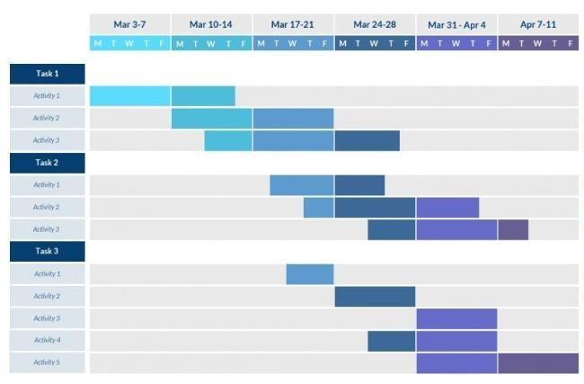

1. **Methodology/ Planning of work**

Methodology will include the steps to be followed to achieve the objective of the project during the project development. This is to be supported by **Architecture Diagram/ DFD/ ER/ Class diagram** to explain the flow of information.

1. **Tools/Technology Used:** 
   1. **Minimum Hardware Requirements**

Hardware required for the development of the project.

* + - **CPU:**
    - **RAM:**
    - **GPU:**
    - **HDD:**
    - **Others(if any):**

* 1. **Minimum Software Requirements**

Software required for the development of the project.

* + - **OS :**
    - (Other Tools Used for Development Like Android Studio, Python etc. with specific version.)

1. **References: [IEEE format]:**

Here specify the description of the study material (Research Papers/other references) referred for the development project.

**Guidelines:**

1. Heading Font Size: 14
2. Content Font Size: 12
3. Font Name: Times New Roman
4. Line Spacing: 1.5”
5. Alignment: Left & Right both Justified
6. Margin: Normal (Top=2.54 cm, Bottom=2.54 cm, Left=2.54 cm, Right=2.54 cm) 7) Page No: At Bottom Right Side

Note: Consider this format for your reference.